Advanced SQL
- SQL Exercise - Advanced concept
Exercise 1: Ranking and Window Functions
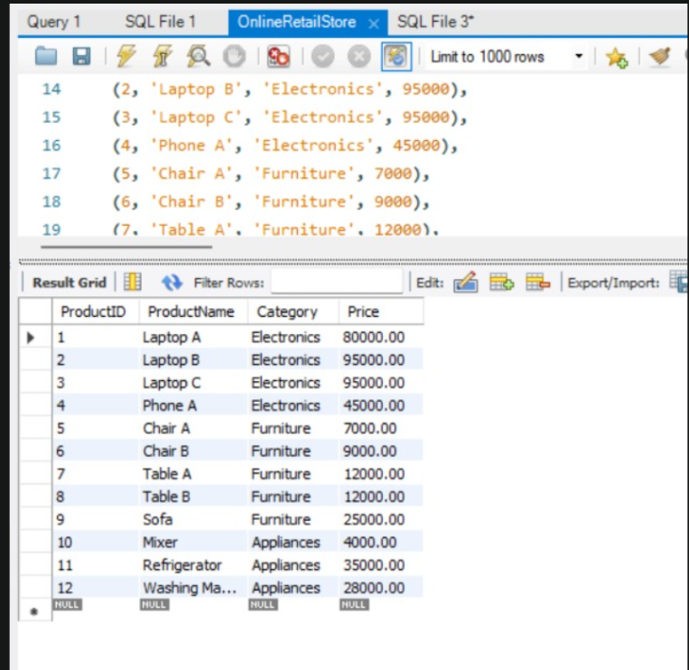

4. SQL Exercise - Stored procedure
Exercise 1: Create a Stored Procedure
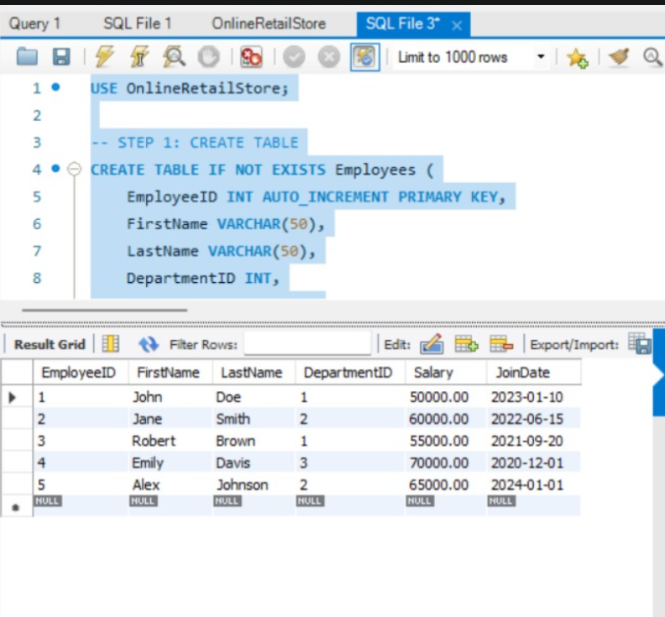

4. SQL Exercise - Stored procedure
Exercise 5: Return Data from a Stored Procedure
